UCLA Chemistry 144 Organic Synthesis
Professor Michael E. Jung
Experiment 3: Synthesis of 5,6-dicarboxymethyl-8-phenylchroman via a Facile Diels-Alder Reaction
Heather Graehl

Abstract
Introduction
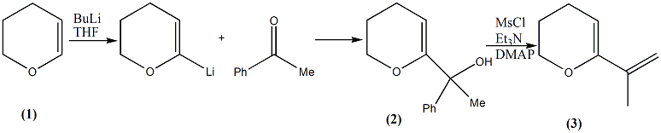
Discussion
Conclusions
Experimental
1-(5,6-dihydro-4H-pyran-2-yl)-1-phenylethanol (2) To a 50mL round bottom flask, 5mL of 3,4-dihydro2Hpyran and 20mL of THF were stirred under N₂ gas. BuLi 1.6 molar solution nin hexane was added dropwise at 0°C and stirred for two hours at 50-65°C. Acetophenone (45mmol) in 10mL THF was added dropwise and stirred for two days at room temperature. Added 100mL dH₂O and stirred for five minutes. Extracted twice with 50mL diethyl ether, dried with Mg₂SO₄ and evaporated solvent to 10.7042g of a brown orange liquid at IR NMR
Alcohol
40.6667h
Spectra

